Peter Julius M. Estacio
Grouped with:
Niño Aloysius V. De Mesa
Christian James S. Madariaga
ENGG 151.01-A
January 28, 2026

Progress Report 1 for Project 1: Normalized Crosscorrelation

As of January 28, 2026, initial progress has been made with Niño Aloysius V. De Mesa and Christian James S. Madariaga to implement basic crosscorrelation using the previous spreadsheet homework as an example. Specifically, a C++ program has been developed to read two signal files, xdata and ydata, process the raw signal values within them, and obtain the crosscorrelation value at l = 0. The two signal files were read using the fstream library, and the raw signal values are stored as double-precision numbers in a vector using the vector library. Once both signal files have been processed, the program iterates through both signals taking the product of the signal values at that relative time. Should the iterator i exceed the finite duration of either signal, the program automatically equates the corresponding signal value to 0. Through each iteration, the resulting product is added to a double-precision variable result until the iterator has exceeded the finite duration of both signals. The value of result, representing the sum of these products, is then finally displayed in the console. A screenshot of this result is shown below.

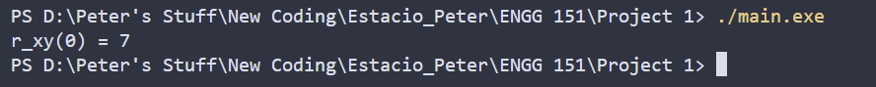
sample screenshot – executable main.exe run and resulting value of r_xy(0)

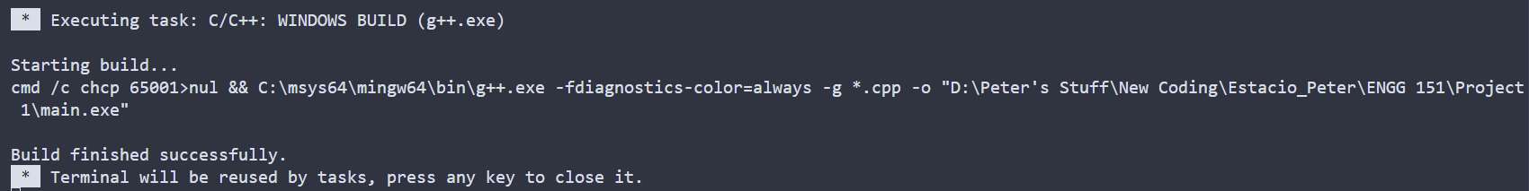
sample screenshot – compilation on Visual Studio Code

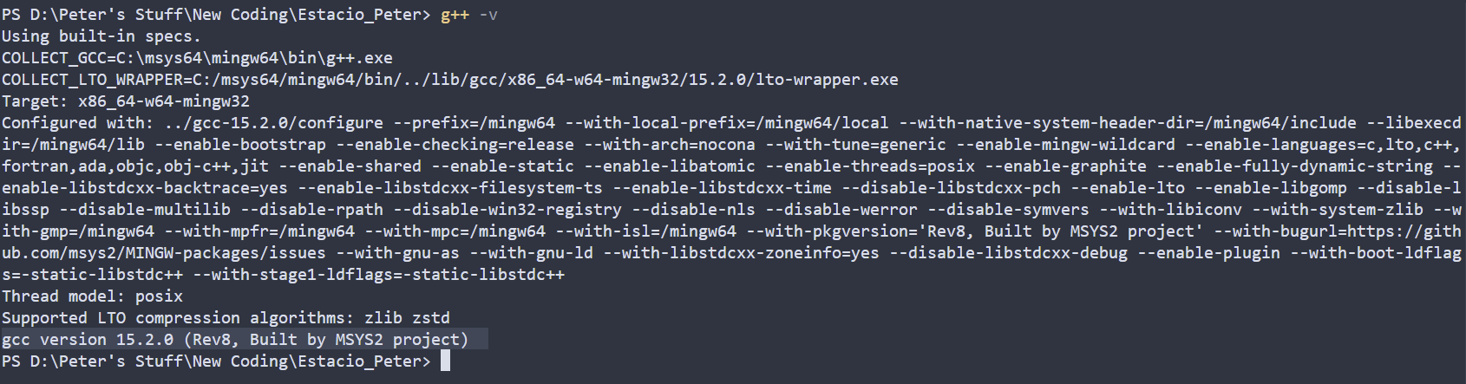
compiler version – gcc version 15.2.0 (Rev8, Built by MSYS2 project)

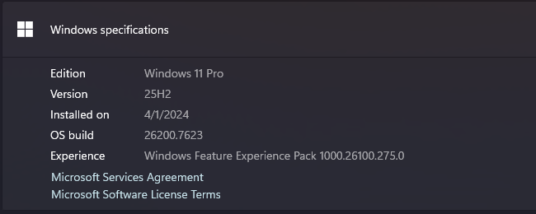
operating system - Windows 11 Pro, 25H2, build 26200.7623
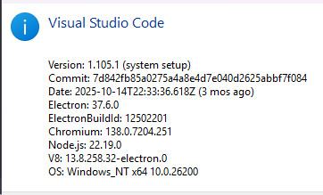
IDE – Visual Studio Code ver 1.105.1

